VIC II POW/PH Enhancement Installation and Configuration
Guide



Author: Joe Parks
Creation Date: February 28, 2006
Last Updated: March 16, 2007
Version: 1.11

Document Control

Change Record

Date | Author | Version | Change Reference
2/28/06 | Joe Parks | 1.1 | Initial Version
3/1/06 | Ron McGinnis | 1.2 | Insertion of installation overview and VistA server installation instructions
4/25/06 | Ron McGinnis | 1.3 | Insertion of software upgrade instructions
4/25/06 | Stuart Frank | 1.4 | Included information on “Unable to save photo to VistA Imaging” error.
4/25/06 | Joe Parks | 1.5 | Included instructions for installing Broker Client Agent and configuring Auto-Signon. Removed instructions for un-installation of VIC I software, since un-install is part of the VIC II installshield
5/3/06 | Joe Parks | 1.6 | Included note that the PICS shortcut server and port values must match the CPRS shortcut server and port values. Changed the phrase: “VIC II Prisoner of War project” to “VIC II former Prisoner of War project”
5/8/06 | Ron McGinnis | 1.7 | Removed test version from KIDS file names.
5/8/06 | Ron McGinnis | 1.8 | Corrected retrieval directory information in server install.
5/26/06 | Joe Parks | 1.9 | Included instructions for installation of CPRS
6/7/06 | Joe Parks | 1.10 | Included instructions for PICS LDAP settings
3/16/07 | Joe Parks | 1.11 | Included updates on Queue File Management and Changing PICS settings

Reviewers

Name | Position
Daniel Maloney | Director
Charles Cadwallader | Project Manager
Michael Boone | Architect
Ellen Hans | Content/Design Lead
Bernard Brauner | Content/Design Lead
Nick Scarnati | Content/Design Lead
Ron McGinnis | Technical Resource
Stuart Frank | Technical Resource
David Zimmerman | Content/Design Resource
John Marple | Content/Design Resource
Jill Coleman | Content/Design Resource

Distribution

Copy No. | Name | Location
1 | PIC_Workstation_Upgrade_Configuration_Guide.doc | http://vaww.va.gov/techsvc/projects/VIC/VIC_II_Installation_Guide.doc
Contents
Document Control 2
Introduction 5
Purpose 5
Background 5
I. Installation Overview 6
II. Installation of VistA Server Patch (DG*5.3*679) 7
III. Install and Configure the VIC II Workstation Software for the first time 9
IV. Upgrading from VIC I to VIC II 15
V. Running the VIC II PICS Software 18
Appendix A – New Feature: Queue Management 21
Appendix B – PICS Error Messages 23

Introduction

Purpose
This guide provides upgrade and system configuration instructions for newly released software components of the veteran identification card (VIC) issuing workstation in support of the VIC II former Prisoner of War (POW) and Purple Heart (PH) enhancement project.

Background
This project involves the design and development of an enhancement to the VIC display to include the POW/PH designation when verified by the Health Eligibility Center (HEC). This work is required in support of requests made by veterans’ organizations to modify the VIC to display POW/PH information.
The VIC II Card Issuing Workstation allows the VHA VIC Issuer to gather information from VistA, to capture a patient picture, to save the picture file to the local VistA Imaging server, and to electronically submit a Card Request. These card requests are collected on the VHA national system called the National Card Management Directory (NCMD). Each day, these Requests are relayed from the NCMD to a vendor who prints and mails the cards to the veterans. The NCMD also provides an on line web browser interface The status of any individual Card Request is available on line from the NCMD, as well as a number of management reports.
This document addresses the VistA server patch installation, workstation software upgrade and configuration of the components that are necessary to ensure the VIC II Workstation operates properly.
There are 5 major Sections of this document.
- Section I provides a high-level installation overview.
- Section II describes the installation of the VIC POW/PURPLE HEART ENHANCEMENT patch DG*5.3*679 on the VistA server.
- Section III describes the initial installation and configuration of the VIC II workstation software if VIC I has not been installed.
- Section IV describes the upgrade and configuration of the VIC II workstation software if VIC I has already been installed.
- Section V describes running the VIC II workstation software.
Note: The information contained in this guide has been validated only for the Windows XP workstation.

I. Installation Overview
This section provides a high-level overview of the installation processes for VIC II.
These processes require modification to both the VistA server software and the PICS workstation software. The following steps must be followed in order to properly complete the upgrade:
- Install the VIC POW/PURPLE HEART ENHANCEMENT patch DG*5.3*679 on the VistA server following the instructions in Section II of this document.
- Install and configure the VIC II workstation software following the instructions in Section III or IV of this document.

II. Installation of VistA Server Patch (DG*5.3*679)
This section explains how to install the VIC POW/PURPLE HEART ENHANCEMENT patch DG*5.3*679. Before starting the patch installation, please review the functional overview, technical components description and software retrieval instructions found in the DG*5.3*679 Patch Description on FORUM in the National Patch Module.
A. Pre-Installation Items:
- Environment Check
Programmer access is required to install this patch. Prior to installation, the installer must ensure the DUZ(0) node of the DUZ array is set to the "@" symbol.

- Users on the System
This patch may be installed with users on the system.

- Software Installation Time
The estimated installation time for this patch is less than 3 minutes during non-peak hours.

- Required Patches
Application | Patch | Build
Registration | DG*5.3*571 | DG*5.3*571
Registration | DG*5.3*641 | DG*5.3*641

B. Installation Steps
- Download the KIDS file DG_53_P679.KID from the ANONYMOUS.SOFTWARE directory of Albany, Hines, or Salt Lake City OIFO to the appropriate directory on your system.

- Use LOAD A DISTRIBUTION option on the KIDS INSTALLATION menu, and enter: DG_53_P679.KID

- From the 'Kernel Installation & Distribution System' menu, select the Installation menu.

- From this menu, you may now elect to use the following options (when prompted for INSTALL NAME, enter DG*5.3*679).

- Backup a Transport Global - This option will create a backup message of any routines exported with the patch.

- Compare Transport Global to Current System - This option will allow you to view all changes that will be made when the patch is installed. It compares all components of the patch (routines, DDs, templates, etc.).

- Verify Checksums in Transport Global - This option will allow you to ensure the integrity of the routines that are in the transport global.

- Print Transport Global - this option will allow you to view the components of the KIDS build.

- Use the Install Package(s) option and select package DG*5.3*679.

- When prompted 'Want KIDS to INHIBIT LOGONs during the install? YES//', it is recommended you answer NO.

- When prompted to 'Want to DISABLE Scheduled Options, Menu Options, and Protocols? YES//', respond YES. When prompted to select the options you would like to place out of order, enter the following:

DGQE VIC RPCS VIC RPC Menu
DGQE BACKGROUND PROCESSING VIC Background Processing

- The Environment Check Installation routine DG53P679 will be automatically deleted from your system after successful patch installation.

III. Install and Configure the VIC II Workstation Software for the first time
This section describes the initial installation and configuration of the VIC II workstation software if VIC I has not been installed.
- Install the CPRS program that is CCOW-enabled (version 22 or higher)
The client version of CPRS must be compatible with the local facility version on the server. The Emerging Health Technologies (EHT) web site will continue to post updated versions of CPRS at the link shown below in C.
- Confirm CPRS version with your facility administrator and obtain the VistA server name and port.
- Create a the following folder: c:\Program Files\Vista\CPRS\
- Access the CPRS link from the page below. Save the zip file to the newly created directory on the Workstation
http://vaww.va.gov/techsvc/projects/VICWorkstationSetup.html
Note: You can also obtain the current CPRS version from the VistA Software FTP site found at URL ftp://ftp.va.gov/vista/Software/Packages/Order%20Entry-Results%20Reporting%20-%20OR/Programs/ <ftp://ftp.va.gov/vista/Software/Packages/Order Entry-Results Reporting - OR/Programs/>. If you use this method to obtain CPRS, you will need to create the shortcut yourself by right clincking the CPRS program and selecting “Create Shrotcut”.
- From within the zip utility, extract the CPRS files to the C:\Program Files\Vista\CPRS\ directory
- In this directory, right-click the icon for CPRSChart.exe and select Send to Desktop (Create Shortcut)
- On the desktop, right-click the newly created shortcut and select Properties
- In the Target field of the shortcut, put the VistA Server Name and Port Number as arguments that follow the path to the executable, as shown in the example that follows. The Server Name parameter is specified with a lower-case “s” and the Port Number parameter is specified with a lower-case “p”.
- Click Apply and then Ok to complete the configuration.
Example: “C:\Program Files\Vista\CPRS\CPRSChart.exe” s=your-VistA-server p=9200

- Double click the CPRS Shortcut on the desktop to be sure that it opens the CPRS sign-on screen. Click Cancel. This also places values in the Windows Registry that we will use later.

2. Configuration of CPRS for launching PICS from the CPRS Toolbar

Sign on to the VistA in programmers mode:

D ^XPAREDIT

--- Edit Parameter Values ---

Select PARAMETER DEFINITION NAME: CPRS GUI TOOLS MENU ORWT TOOLS MENU CPRS GUI Tools Menu

ORWT TOOLS MENU may be set for the following:

1 User USR [choose from NEW PERSON]
2 Location LOC [choose from HOSPITAL LOCATION]
2.5 Service SRV [choose from SERVICE/SECTION]
3 Division DIV [choose from INSTITUTION]
4 System SYS [IMGDEM01.MED.VA.GOV]

Enter selection: 4 System IMGDEM01.MED.VA.GOV

---------- Setting ORWT TOOLS MENU for System: IMGDEM01.MED.VA.GOV ----------
Select Sequence: ?

Sequence Value
-------- -----
1 Display Patient EKGs="c:\program files\vista\imaging\EKGDisplay.exe"
3 VistA Imaging Display="c:\program files\vista\imaging\imgvwp10.exe" %
4 VistA Imaging Capture="c:\program files\vista\imaging\tele19n.exe" %D
10 BCMA="c:\program files\vista\bcma\bcma.exe" %DFN %MREF %SRV %PORT
15 BCMAPAR="c:\program files\vista\bcma\bcmapar.exe" %DFN %MREF %SRV %PO
16 VIC Issuer="C:\Program Files\MAXIMUS\PICS Workstation\PICSWorkstation

Select Sequence: 16

Sequence: 16// 16
Name=Command: VIC Issuer="C:\Program Files\MAXIMUS\PICS Workstation\PICSWorkstation.exe" s=%SRV p=%PORT
Select Sequence:

- Install the Sentillion Vergence Locator -
This will enable CCOW communication between CPRS and PICS.
- Obtain the DNS name for the Sentillion CCOW context vault from the facility network administrator. (This is a network server that will handle the context session established on the VIC Workstation.)
- Open the WinZip file from the following link
  - http://vaww.va.gov/techsvc/projects/VIC/SentillionVergenceLocator.zip
  - or obtain the Sentillion Vergence Desktop Components v 3.3. CD.
- Scroll through the files in the WinZip listing until the Setup.exe executable is shown
- Double click the Setup.exe executable and accept all defaults.
- When prompted for the Virtual IP address of the context vault specify the DNS given by the facility network administrator. Note: To view the Sentillion ReadMe file for the installation you will need to install Adobe, however it will not be necessary to view that file.
Note: If the CCOW server has not been activated, then a full install of the Sentillion Vergence locator must be performed. When performing step 7d above, installation defaults must be accepted for all Sentillion Vergence components.

Example: ccv.yourserver.med.va.gov
4. Provide VistA access for all VIC Workstation operators
- Provide a list of VIC Workstation operators to the facility VistA Administrator to ensure that all VIC Workstation operators have VistA accounts that are configured for multiple sign-on and auto-sign on.
- To ensure that VIC Workstation operators are able to store pictures in VistA imaging, MAG WINDOWS must be implemented as a secondary menu option. No security keys are required to view the photos in VistA Imaging.
To ensure that VIC Workstation operators are able to retrieve veteran demographic data from the VistA Registration database, the VIC RPC Menu [DGQE VIC RPCS] option must be implemented as a secondary menu option
5. Establish NCMD access for all VIC Workstation operators
The facility network administrator must add the domain accounts of all VIC Workstation operators to the VHAV##VICWrite global group.
Other VHA staff may only need Read access to the NCMD data. Staff who need to view the veteran data and will use the Web Browser interface should be added to the VHAV##VICRead global group. Examples would include the Police who may need to access the veteran pictures when trying to locate a missing patient, or management who need access to the management reports.
To locate the VHAV##VICWrite or VHAV##VICRead global groups in your domain, the following steps may be taken:
- Launch Active Directory Users and Computers
- Right click on their domain and select Find (if the person is not in the VISN being searched you will have to first select “Connect to domain”).
- Type in the name of the group (e.g. vhav20VICwrite)
- Hit return.
6. Install the VIC II Software
- Click the following link: (WinZip will be initiated)
http://vaww.va.gov/techsvc/projects/VIC/PICS_Workstation_v2[1].04b1.zip
- Click the Open button on the WinZip dialog box
- Double-click the Setup.exe file that will be shown in the WinZip listing. (Depending on the version of WinZip, you may be prompted to confirm that Setup.exe is to be initiated.)
- The installation will begin – accept all defaults
- A Shortcut will be created on the desktop
- Right-click the newly created Shortcut and select Properties
- In the Target field of the shortcut, key in the VistA server name and port number as arguments, that follow the path to the executable. The server name parameter is specified with an “s” and the port parameter is specified with a “p”. Please note that this parameter is case-sensitive. (Note: The PICS Workstation server and port values should match those found in the CPRS Chart shortcut.)
Example:
“C:\Program Files\MAXIMUS\PICS Workstation\PICSWorkstation.exe” s=your-VistA-server p=9200

- Click Apply then Ok, to complete the configuration
7. Configure PICS with the LDAP setting for the National Card Management Directory
- Launch CPRS from the desktop shortcut. Supply the VistA Access Code and Verify Code.
* Note: CPRS must be launched in order for PICS to run.
- From the CPRS toolbar, click Tools, then VIC Issuer.
- On the PICS toolbar, click Patient, then Settings.
- In the LDAP Address field, enter the following:
LDAP://veterans1.oneva.va.gov/DC=veterans1, DC=oneva, DC=va, DC=gov
- Click the Ok button.
LDAP://veterans1.oneva.va.gov/DC=veterans1, DC=oneva, DC=va, DC=gov

8. Load the VistA Broker to allow CPRS to communicate with your VistA server
- Run the executable for the VistA RPCBroker version 1.1 software from the following link:
http://vista.med.va.gov/broker/archives/internal/v_1_1/xwb1_1ws.exe
- Accept all defaults.
9. Configure VistA auto sign-on and multiple sign-on for all VIC Workstation operators
a) Provide a list of VIC Workstation operators to the facility VistA Administrator to ensure that all VIC Workstation operators have VistA accounts that are configured for multiple sign-on and auto-sign on.
b) To ensure that VIC Workstation operators are able to store pictures in VistA imaging, MAG WINDOWS must be implemented as a secondary menu option. No security keys are required to view the photos in VistA Imaging.
c) To ensure that VIC Workstation operators are able to retrieve veteran demographic data from the VistA Registration database, the VIC RPC Menu [DGQE VIC RPCS] option must be implemented as a secondary menu option.

10. Verify the registry entry for the VistA server name and port number.
The following instructions are for changing the targeted VistA Server name and port, to the required values as confirmed with your facility administrator.
- Using Start/Run from the bottom toolbar, type regedit to make an entry in the registry
- In the Registry Editor, expand the HKEY_LOCAL_MACHINE folder
- Expand the SOFTWARE folder
- From within the SOFTWARE folder, expand Vista
- From within Vista, click Broker
- Right click Servers
- Verify the required values for servername and port as confirmed with your facility administrator (Note in the example below, that there is no space between the comma and the Port Value).
Example: isw-VistA-server,9200. Note: the data value should be left blank as shown

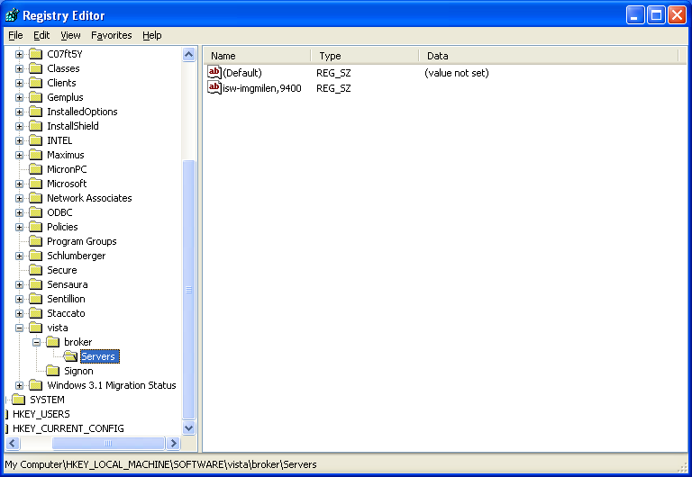
11. Set the parameters for the VIC II Patient Image Capture software (PICS) shortcut
  - Right-click the shortcut on the desktop for the PICSWorkstation.exe executable and select Properties
  - Put the VistA Server Name and Port Number in the shortcut Target field as arguments that follow the path to the executable. The server name parameter is specified with an “s” and the port parameter is specified with a “p”. Please note that these parameters are case-sensitive and must be lower-case.
Example: “C:\Program Files\MAXIMUS\PICS Workstation\PICSWorkstation.exe” s= your-VistA-server p=9200

Congratulations. All the software has been configured. It is good practice to reboot your system after any software installation, so please reboot your system now. In order to test your configuration, please go to section II to run the PICS VIC II software and submit a test patient card request.

IV. Upgrading from VIC I to VIC II
This section describes the steps required to upgrade an existing operational VIC I workstation to VIC II software.
  - Locate the PICS Workstation shortcut on the Desktop. 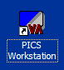
  - Right click the shortcut and select Properties from the pop-up menu. Locate the Target field on the Shortcut tab and copy the server address and port values following the .exe command. These values are overwritten by the installation and will need to be re-entered in the shortcut at the completion of the installation. The example below highlights the location of the values. (Note: The PICS Workstation server and port values should match those found in the CPRS Chart shortcut.)
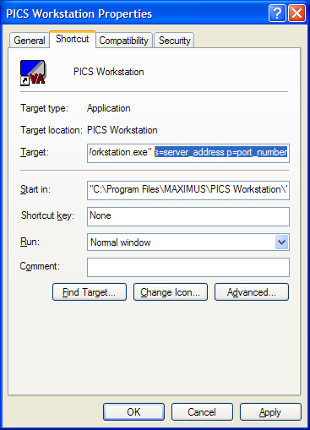

  - Retrieve the zip file containing the VIC II PICS software using the retrieval instructions in the VIC POW/PURPLE HEART ENHANCEMENT (DG*5.3*679) patch description.
  - Extract the Setup.exe file to the Desktop and double-click the Setup.exe file.
  - The following dialog box will display indicating that this is an upgrade and not a new install. Click Yes to continue.

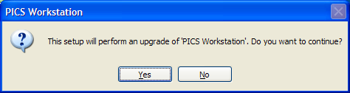

  - After the InstallShield Wizard completes the install preparations, the following screen will display. Click Next to continue.
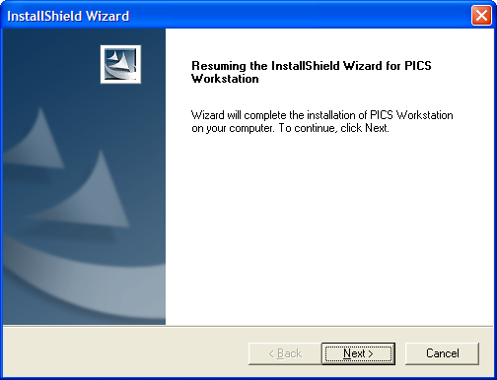

  - After the InstallShield completes the installation, the following screen will display. Click Finish to complete the installation.
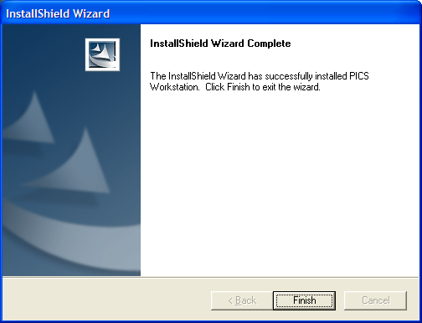

  - Enter the server and port values copied in Step 2 into the updated PICS Workstation shortcut on the Desktop.
Note: The PICS Workstation server and port values should match those found in the CPRS Chart shortcut.

  - Congratulations. The VIC workstation has been successfully upgraded.

V. Running the VIC II PICS Software
To ensure all installation and configuration procedures have been completed successfully, the following section provides instructions for submission of a test patient card request.
- Launch CPRS from the desktop shortcut. Supply your VistA Access Code and Verify Code when prompted.
- Select a veteran from the listing. For an initial test, select a veteran who is also a local VA employee.
- Launch PICS from the desktop shortcut and note the veteran POW/PW status
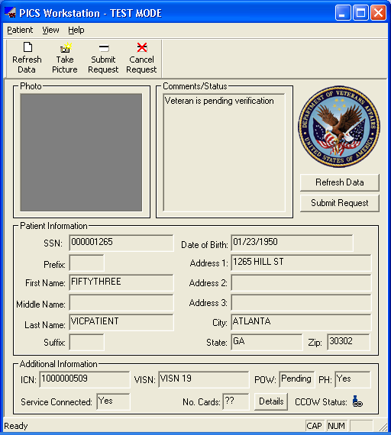
- Capture, crop and save a picture
- Submit the VIC request
- Observe the window that indicates a successful submission
(Note: The PICS user guide contains detail of the software functionality.)
- You may check on the status of any request on-line at any time by opening your Internet Explorer Web Browser and going to URL https://vaww.etech.med.va.gov/VIC/index.asp. Your Network Authentication Identity is used to transparently access the NCMD for this information once your Workstation browser is configured as described in Section I or III.
- You may cancel the card request by clicking the Cancel Request button on the PICS toolbar.
To activate the PICS audit log;
- On the PICS toolbar click Patient and then Settings. (Please note also, the settings for Using LDAP User Name and Password and for Storing pictures in VistA Imaging);
- In the Settings window click the Activate Audit Log checkbox
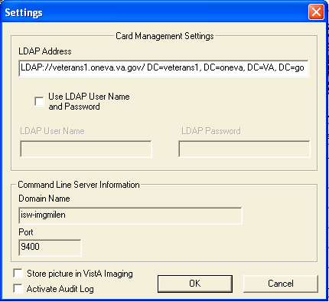
3. The PICS audit log is located in the C:\Program Files\MAXIMUS\PICS Workstation directory as shown below
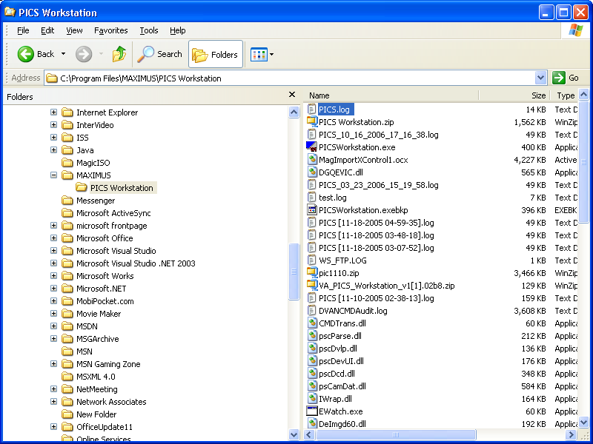
Note: A DOS bat file or other means of launching both applications is being established. PICS will also be enabled for launch from the CPRS tools menu.

Appendix A – New Feature: Queue Management
This release of the PICS VIC II software allows user management of the queue. Queuing of data on the workstation was implemented to handle network disruptions and is automatically de-queued by the PICS application. However the VIC II release allows queued requests to be viewed, removed or resubmitted from the following window:

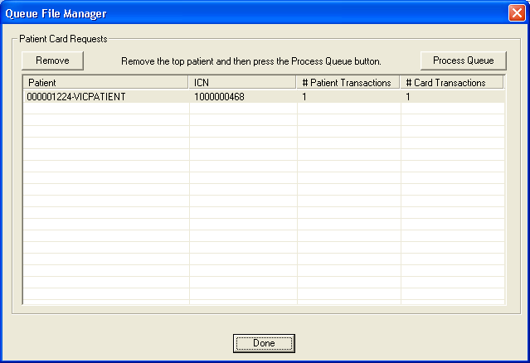

If a card request fails to transmit to the NCMD it will be saved to the PICS queue. There are three conditions that cause card requests to be written to the queue:

  - Issues of User Authorization:
Everyone who submits VIC card requests must have membership in the VHAV##VICWrite global group for their site. The facility network administrator must add the domain accounts of all VIC Workstation operators to the global group for each site.
  - Temporary Network Issues:
Each time a card request is issued, PICS checks to confirm that the request can be transmitted across the network prior to attempting the transmission. If PICS determines that the card request transaction cannot be completed, PICS saves the card request to the queue and then checks network conditions each time PICS is opened and each time a new card request is transmitted. When PICS determines that the network is clear it transmits the request(s) from the queue before transmitting the current card request.
3. Incomplete Card Requests that block Transmission:
Although PICS tries to ensure that each card request can be completely transmitted before attempting the transmission, there may be times when card requests are incompletely transmitted. When this occurs it blocks the transmission of additional card requests. The error message: “Unable to process off-line transactions” is generated. These incompletely transmitted card requests are easily identified because they show a mismatch between the “#Card Transactions” and the “#Patient Transactions” in the queue list. Incompletely transmitted card requests can be removed from the queue via the “Remove” button on the queue management window. Once these incompletely transmitted card requests are removed, the rest of the card requests will be released from the queue either: when the user clicks the “Process Queue” button; or when the next card request is transmitted; or the next time that PICS is initiated.

Removing Incomplete Card Requests from the Queue:
We only need to remove a card request from the queue when we encounter the “Unable to Process Offline Transactions” message and we see a mismatch between the “#Card Transactions” and the “#Patient Transactions.
After the card request has been removed from the queue the card and veteran information is still available in the following folder:

Location of Deleted Card Requests
C:\WINDOWS\MAXIMUS\Deleted Transactions

We can use the picture from this folder to resubmit the card request.

Excessive Numbers of Batched Requests:
If an excessive number of batched card requests accumulate, it may be important to confirm whether some of the batched requests have accumulated from a prior version of PICS. Upgraded versions of PICS cannot process batched card requests from earlier versions of PICS. In such a case, it will be necessary to re-install the earlier version of PICS, in order to process the card requests from that earlier version.

Appendix B – PICS Error Messages
Error Message Text | System Cause
Unable to find veteran in database. | Patient record number is not valid. Should not happen.
A previous VIC request for the veteran, entered on entry_date from your facility, is awaiting a National ICN or Enrollment Status update. If no update is received by expiration_date, the previous request will expire, allowing you to enter a new request. | A pending request exists in a HOLD status.
Unable to determine veteran's Sex. | Sex field is null.
Unable to determine veteran's Social Security Number. | SSN field is null.
Unable to determine veteran's complete Date of Birth. | DOB field is null or does not include day of birth.
Unable to determine veteran’s Name. | FAMILY NAME component is null.
Unable to determine a mailing address. | Attempting to use the facility address as the mailing address, but there is a problem with INSTITUTION file for local site.
Unable to determine the STREET1 field of the permanent mailing address. | Permanent address STREET1 field is null.
Unable to determine the STREET1 field of the temporary mailing address. | Temporary address STREET1 field is null.
Unable to determine the STREET1 field of the confidential mailing address. | Confidential address STREET1 field is null.
Unable to determine the STREET1 field of the facility mailing address. | Facility address STREET1 field is null.
Unable to determine the CITY field of the permanent mailing address. | Permanent address CITY field is null.
Unable to determine the CITY field of the temporary mailing address. | Temporary address CITY field is null.
Unable to determine the CITY field of the confidential mailing address. | Confidential address CITY field is null.
Unable to determine the CITY field of the facility mailing address. | Facility address CITY field is null.
Unable to determine the STATE field of the permanent mailing address. | Permanent address STATE field is null.
Unable to determine the STATE field of the temporary mailing address. | Temporary address STATE field is null.
Unable to determine the STATE field of the confidential mailing address. | Confidential address STATE field is null.
Unable to determine the STATE field of the facility mailing address. | Facility address STATE field is null.
Unable to determine the ZIP field of the permanent mailing address. | Permanent address ZIP field is null.
Unable to determine the ZIP field of the temporary mailing address. | Temporary address ZIP field is null.
Unable to determine the ZIP field of the confidential mailing address. | Confidential address ZIP field is null.
Unable to determine the ZIP field of the facility mailing address. | Facility address ZIP field is null.
Unable to determine veteran's Service Connected Indicator. | Should never happen.
Unable to determine a source facility. | There is a problem with INSTITUTION file for local site.
Unable to save photo to VistA Imaging | Connectivity issues with VistA Imaging – review PICS log file to get details about the error. Enter a Remedy call with the log file details to get help from the VistA Imaging support team

Section III provides instructions for the initial PICS software installation. Section IV provides instructions for the upgrade of an existing PICS installation.
Additional resources are available from the following link: http://vaww.va.gov/techsvc/projects/VICReplacementPhase2.html

